Testing on E90-DTU(900SL30) – Configuration Mode and Transmission Functions

Prepared by

PM Ir Dr Tee Kian Sek

Date: 24 February 2021

Table of Contents

1 Objectives 3

2 References 3

3 The setup 3

4 Operating Mode 4

5 Configuration Software 5

6 Interpretation of the settings 6

# Objectives

1. To study LoRa unit and its configuration settings.
2. To figure out transmission functions [fixed, broadcast (broadcast address | Monitor address)].

# References

1. E90-DTU(900SL30)_UserManual_EN_v1.0.pdf
2. E90-DTU(900SL30)_UserManual_CN_V1.1.pdf
3. Configuration software for E90-DTU, RF_Setting(E22-E90(SL)) V2.0.exe
4. Product website, <https://www.ebyte.com/>

# The Setup

For configuration, we need:

1. A DC12V power supply (here- an adaptor is used)
2. RS232-to-USB converter
3. E90-DTU
4. A laptop (Window 10)

Like figure below.

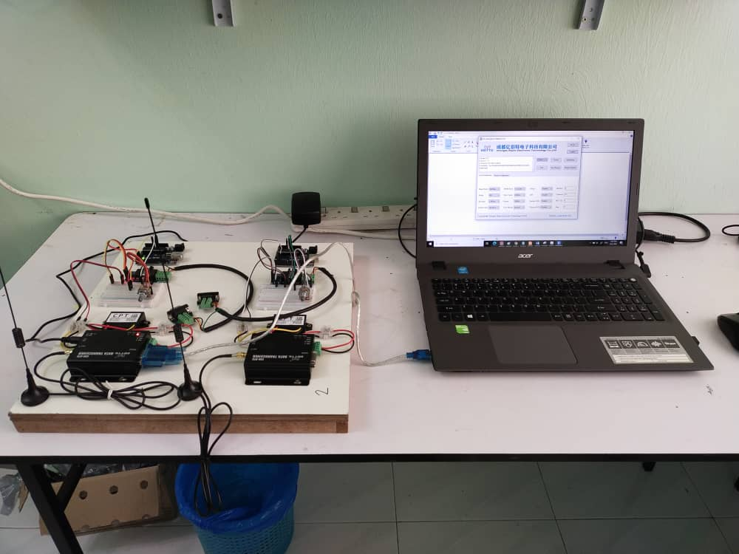

For trials on transmission functions [fixed, broadcast (broadcast address | Monitor address)], setup as figure below. The aim is to choose a transmission function for 1 master 3 clients (1:3 mode), where the client nodes read sensory data and send to the master node.

*Note: Figure below shows four nodes. They are assembled on two wooden pallet neatly. Good for presentation.*

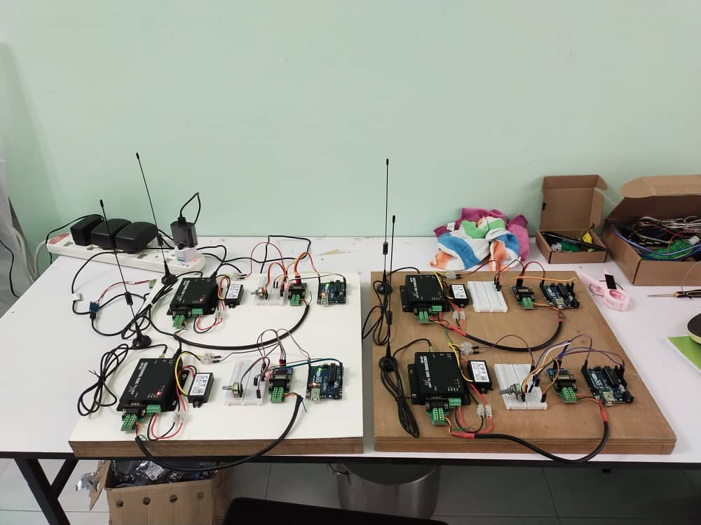

# The Configuration

## Operating Modes

Information retrieved from the user manual.

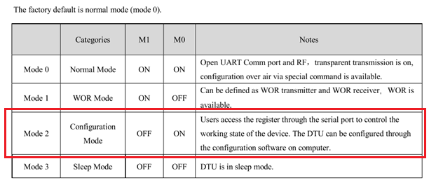

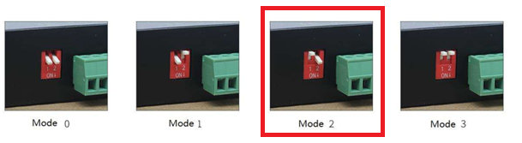

Figure 1: Configuration Modes

Before power ON, switch the function operating selector switches to [OFF, ON]. Power ON, connect RS232-to-USB converter between E90-DTU and a laptop. Click open the configuration software provided by the company.

## Configuration Software

Make sure E90-DTU is switched to Mode 2 - Configuration Mode. The configuration software would not read/write any parameters if not in Mode 2.

1. Click open the configuration software, RF_Setting(E22-E90(SL)) V2.0.exe.
2. Plug in RS232-to-USB converter to any USB-port and notice the COM port number. Select the right port number.
3. At the configuration software, select the COM port and click “Open”.
4. Once connected, click “Get” to read all parameters from E90-DTU.

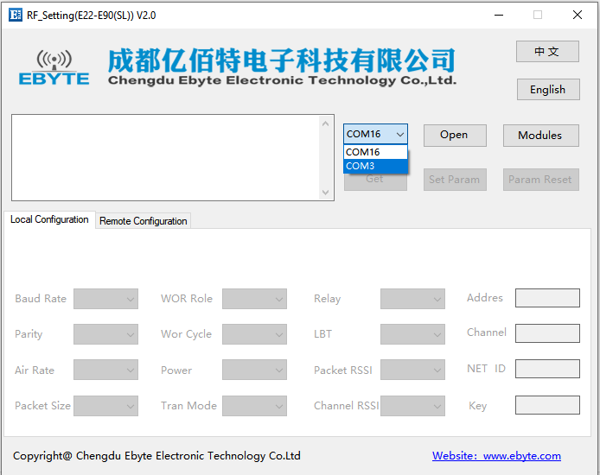

Figure 2: Configuration software by Ebyte

Before “Open”. Choose the right COM port.

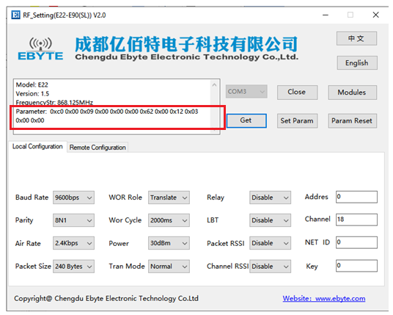

Figure 3: Reading configuration settings

After “Get”. This is the default factory settings.

*Note:*

*Default factory settings may be different with the description stated in the user manual.*

## Interpretation of the Settings

Refer to the user manual – E90-DTU.

The data structure: (In byte)

|  |  |  |  |
| --- | --- | --- | --- |
| command | Start address | length | Parameter |

*Note: parameter means the registers being read. Refer to* [4.4Definition of Registers]*.*

From [4.2 Configuration Software], the default parameter: (in Hex)

0xc0 0x00 0x09 0x00 0x00 0x00 0x62 0x00 0x12 0x03 0x00 0x 00

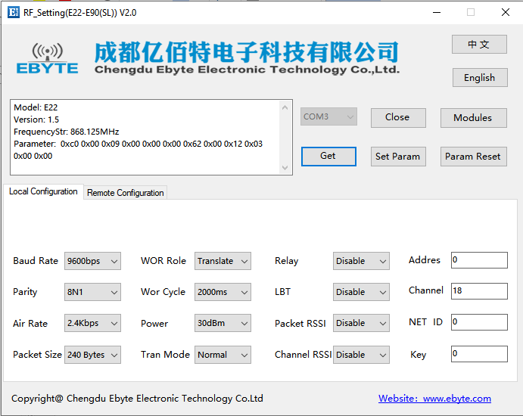

The interpretation:

|  |  |  |  |  |  |
| --- | --- | --- | --- | --- | --- |
| 0xc0 | 0x00 | 0x09 | 0x00 | 0x00 | 0x00 |
| Command | Start Address | Length | ADDH | ADDL | NETID |

|  |  |  |  |  |  |
| --- | --- | --- | --- | --- | --- |
| 0x62 | 0x00 | 0x12 | 0x03 | 0x00 | 0x00 |
| REG0 | REG1 | REG2 | REG3 | CRYPT_H | CRYPT_L |

The data structure reads from address 0x00 and followed by data reading of length 9-bytes.

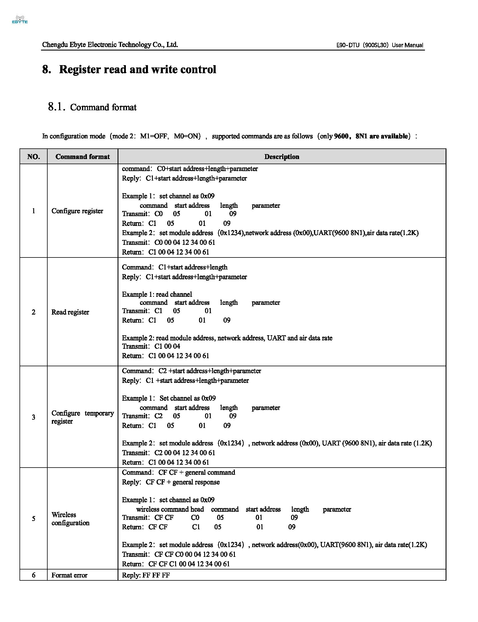

## Definition of Registers

Refer to User Manual.

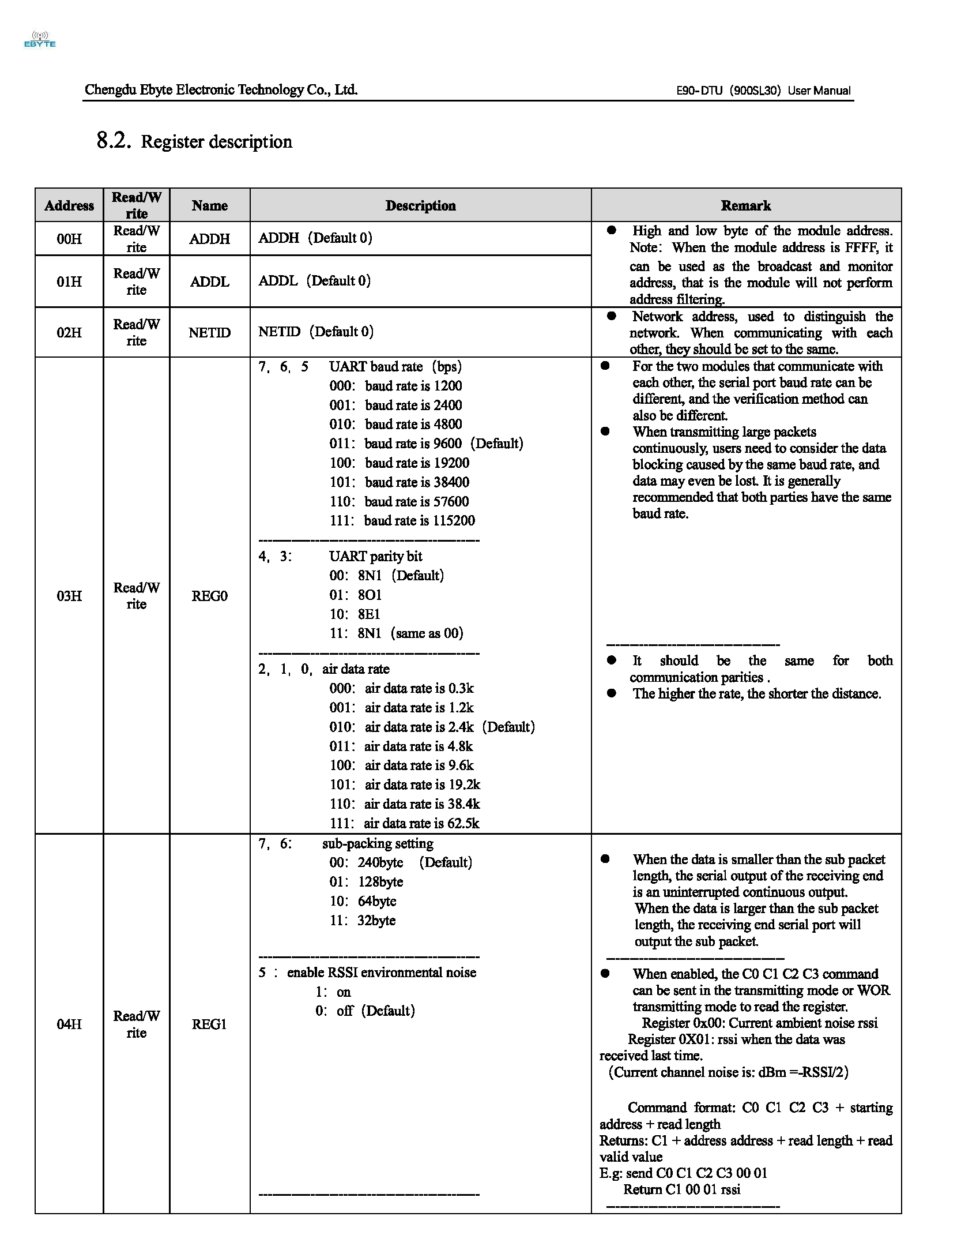

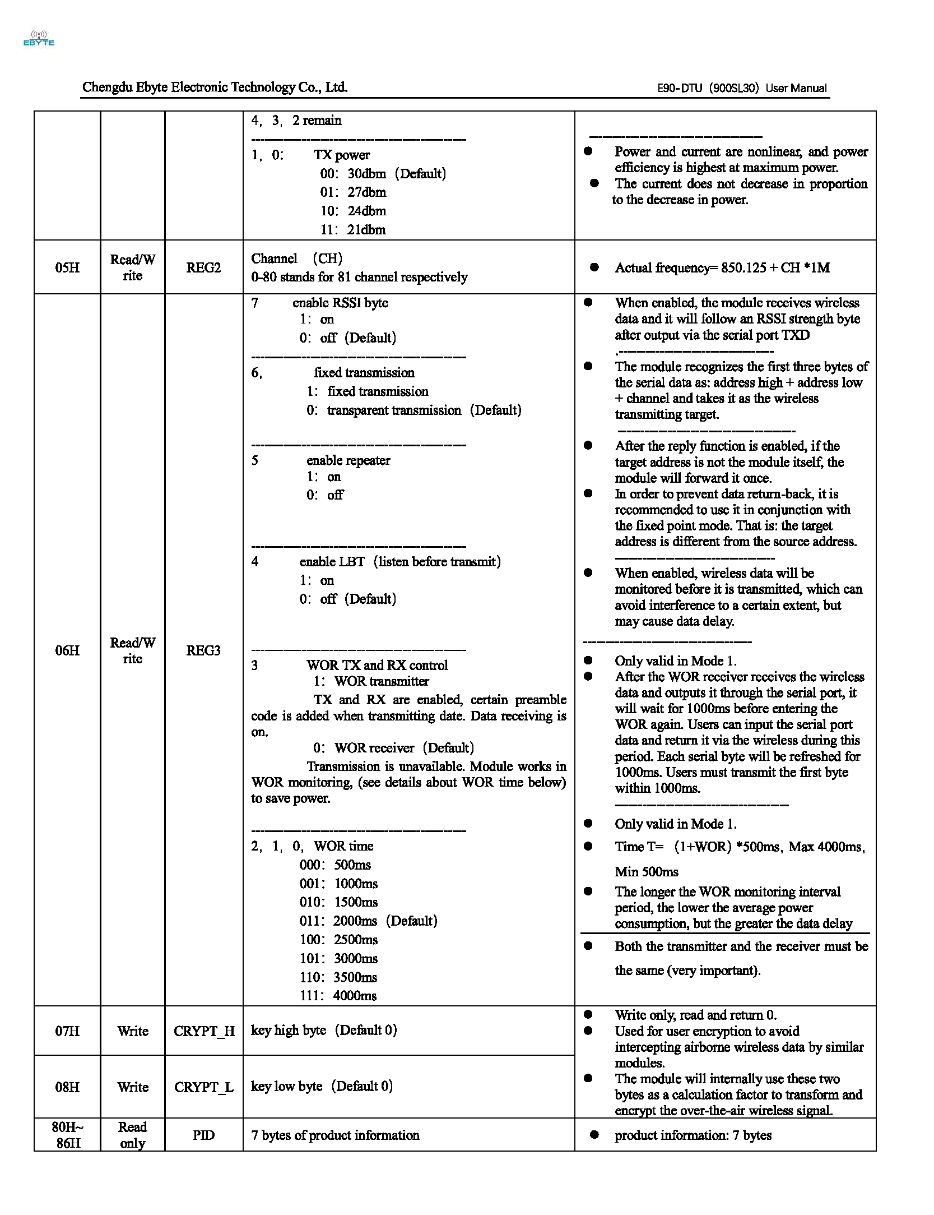

## Using a Serial Terminal

Operating mode : Mode 2

Instead of using the provided configuration software, the configuration software, RF_Setting(E22-E90(SL)) V2.0.exe., it is possible to use a typical serial terminal to read/write E90-DTU.

Referring to the user manual for data structure and registers.

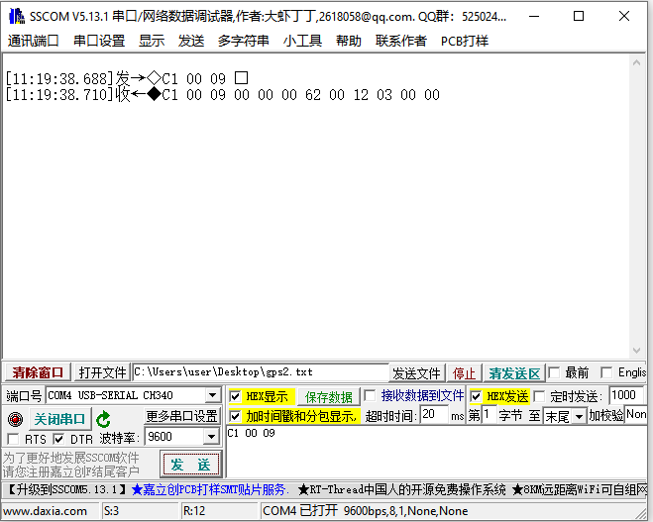

Figure 4: Configuring using a serial terminal

1. Sending HEX. Example: C1 00 09
2. Receive: C1 00 09 00 00 00 62 00 12 03 00 00
3. Refer to E90-DTU structure and registers

# The Transmission Functions

To figure out transmission functions [fixed, broadcast (broadcast address | Monitor address)].

Materials: 4 units of E90-DTU(900SL30)

Objectives: To arrange a network of 1:3, where all clients send data to a master.

Client 1

Client 2

Client 3

Master

Figure 5: My LoRa network and naming

## Default Settings

Operation Mode: 0

Configuration of E90-DTU: (default) C1 00 09 00 00 00 62 00 12 03 00 00

By default:

1. all E90-DTU are in “Transparent Transmission”.
2. Address = 0x00 0x00
3. Channel = 0x12
4. Baud rate = 9600, 8N1
5. And others🡪 see user manual.

*Note: See “Fixed Transmission” for difference.*

### Method

1. Label E90-DTU as “Master”, “Client 1”, “Client 2, “Client 3”.
2. Power ON all E90-DTU.
3. Connect each E90-DTU to a laptop via RS232-to-USB or RS485-2-USB (The reason: I have two units of RS232-to-USB and two units of RS485-2-USB.)
4. At laptop, open four windows of serial terminals.

### The results

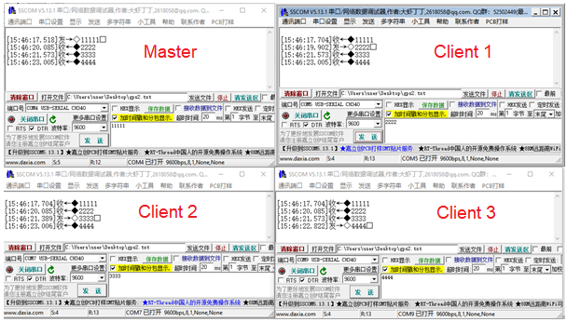

Figure 6: Results deploying default settings

### Comments

1. No configuration is made.
2. Each node can send data; and being received by other nodes.
3. No designation of master or client node.
4. Each node could broad-cast the data.
5. Received data have no meta-data about the sender. No identifier.

### Suggestion

1. If the default settings are applied for 1:3 network (1 master to receive 3 clients), the data need to carry identifier.

Example:

Data structure: [identifier] [separator] [data]

“N1, xxxx, yyyy, ….”

1. Design of data structure

Node 1 🡺 “N1, xxxx, yyyy”

Node 2 🡺 “N2, xxxx, yyyy”

Node 3 🡺 “N3, xxxx, yyyy”

Node 4 🡺 “N4, xxxx, yyyy”

## Fixed Transmission

### Method

1. Configuration
   1. Switch each node to Mode 2 (Configuration Mode).
   2. Set the address and channel as indicated in the figure below.
   3. [address, channel]

Master [0001, 02], Client 1 [0003, 04], Client 2[0005, 04], Client 3[0007, 06]

* 1. Set to “Fix Transmission” - see REG3
     1. First 3 bytes would be taken as serial data as: address high + address low + channel + data
     2. Ex: 00 03 04 AA BB CC

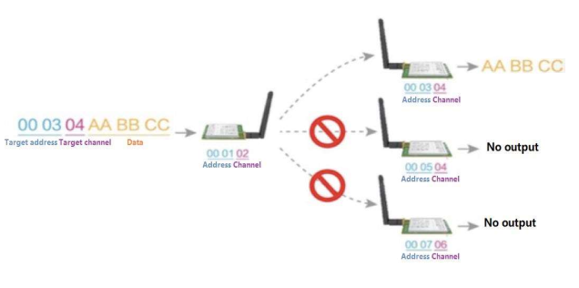

Figure 7: Fixed Transmission and configuration (from user manual)

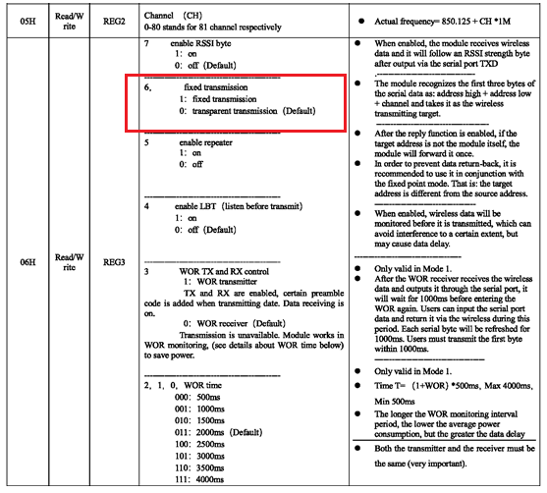

1. Switch to Mode 0 (Normal Mode).
   1. Open multiple serial terminal and monitor each node
   2. Send from master (in Hex)
      1. Note: each node is set as fixed transmission.
      2. Try sending to target and data
      3. Example 🡪 00 03 04 AA BB CC
   3. Verify the data received at each node.

### Results

Configuration of fixed transmission – using configuration software, RF_Setting(E22-E90(SL)) V2.0.exe.

Figure below shows the configuration of Master node. [address, channel] = Master [0001, 02].

The parameters are: Refer to *[4.4 Definition of Registers]*.

|  |  |  |  |  |  |
| --- | --- | --- | --- | --- | --- |
| 0xc0 | 0x00 | 0x09 | 0x00 | 0x01 | 0x00 |
| Command | Start Address | Length | ADDH | ADDL | NETID |

|  |  |  |  |  |  |
| --- | --- | --- | --- | --- | --- |
| 0x62 | 0x00 | 0x02 | 0x43 | 0x00 | 0x00 |
| REG0 | REG1 | REG2 | REG3 | CRYPT_H | CRYPT_L |

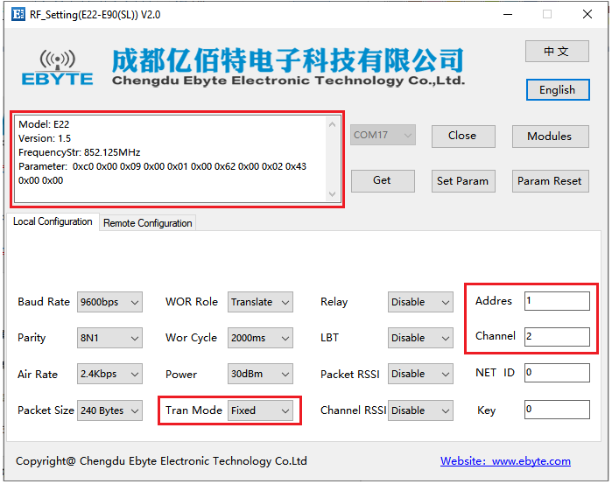

Figure 8: Configuration of Fixed Transmission

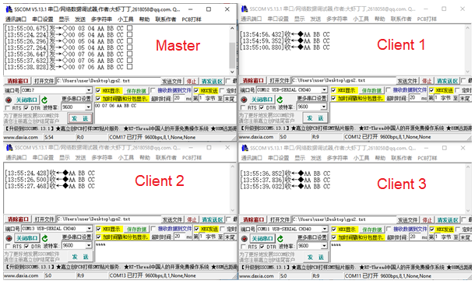

Figure 9: The results of Master and three other clients

### Comments

1. Since all nodes has different address, we could specify a target and send data.
2. Example –
   1. Master to client 1
   2. Client 1 to client 2
   3. Many more, only in 1 to 1 direction.
3. The received data has no identifier. No idea from which source.
   1. Example
   2. Master send data = AA BB CC
   3. Client 1 received = AA BB CC
   4. Receiver has no identifier about the source.

### Suggestion

1. Sent data is suggested to carry identifier as proposed in [5.1.4 Suggestion]

## Broadcasting Transmission

### Method

The network and naming as [5 The Transmission Functions]

Setting as Address, Channel and Fixed Mode

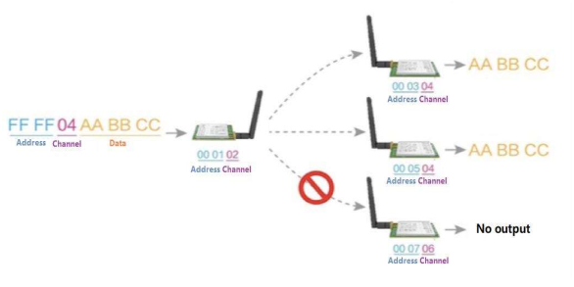

1. Switch to Mode 0 (Normal Mode) after configuration.
   1. Open multiple serial terminal and monitor each node
   2. Send from master (in Hex)
      1. Note: each node is set as fixed transmission.
      2. Try sending to target and data
      3. Example 🡪 FF FF 04 AA BB CC
   3. By indicating target address as FF FF and Channel = 04
      1. All address with Channel = 4 would receive the data

### Results

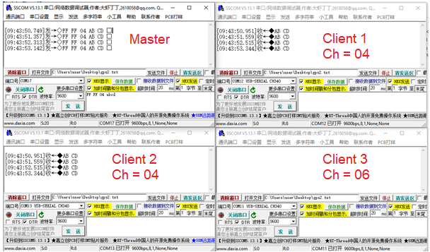

### Comments

1. By sending from master, FF FF 04 abcd 🡪 all clients with channel = 04, would receive the data.
2. The data sent and received has no identifier about the source.

### Suggestion

1. Sent data is suggested to carry identifier as proposed in [5.1.4 Suggestion]